DATA ACT REPORT

Displays the visualization(s) produced from wrangled data.

According with our dataset clean called all_data and saved as twitter_archive_master.csv this document will provide the graphs obtained and its respective interpretation.

1. First, what is the 10 most popular dog breed?

Using the code: sort_values() and value_counts(), which sort by the values along either axis from highest to lowest value. Mainly column was image_predic.

**popular_dogs=all_data.image_predic.sort_values().value_counts().head(11)**

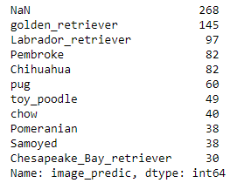

As we can observe, highest number is NAN which means that we do not have that data. Nevertheless, the most popular dog was golden_retriever with 145 follows by Labrador_retriever with 97.

Importing important libraries such as **import matplotlib.pyplot as plt** I plotted the 10 most popular dogs and the code is:

**popular_dogs.plot(kind = 'barh');**

**plt.title('Top 10 popular Breed of dog')**

**plt.xlabel('Count')**

**plt.ylabel('Dog breed');**

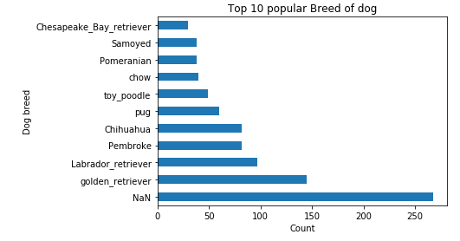

1. What is the 10 least popular dog breed?

I did the same procedure from first point and the code was:

**least_popular=all_data.image_predic.sort_values( ascending=True).value_counts().tail(10)**

**least_popular**

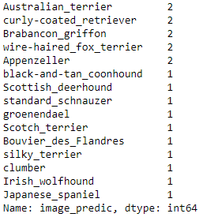

Plotting those data, we obtain:

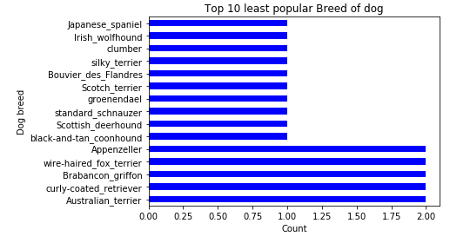

If I compare with the first graph, I could say that the top 10 least popular dogs and I included 5 dogs more it could be insignificant since the number is smaller.

1. What are the favorite dogs? It means which has the most like.

Using the code: sort_value and getting the first 10 value. The main columns were favorites and image_predic.

**favorite_dogs= all_data[['favorites','image_predic']]**

**favorite_dogs_popular=favorite_dogs.sort_values(by=['favorites'],ascending=False).head(10)**

**favorite_dogs_popular**

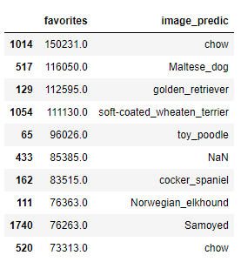

Plotting the last table I got:

**favorite_dogs_popular.plot(kind='barh',x='image_predic',y='favorites', alpha = 0.5, color='Blue');**

**plt.title('Top 10 with more likes')**

**plt.xlabel('Likes')**

**plt.ylabel('Dog breed');**

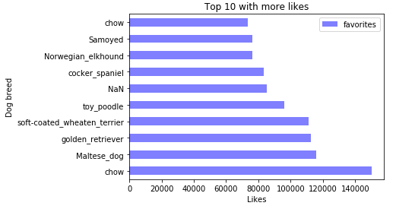

Chow is the favorite follow by Maltese_dog. Effectively, golden_retriever has more like which match with the most popular dogs.

1. What does dog obtain more retweets?

Focus in the columns retweets and image_predic I could filter which dog has more retweets.

**retweets_dogs= all_data[['retweets','image_predic']]**

**retweets_dogs_most=retweets_dogs.sort_values(by=['retweets'],ascending=False).head(10)**

**retweets_dogs_most**

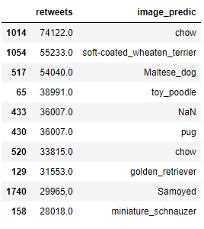

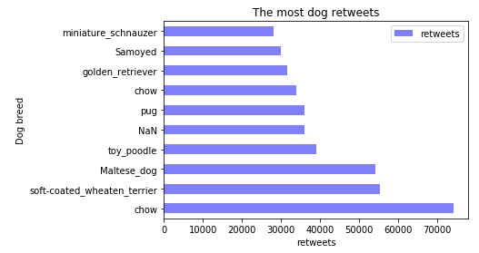

Chow dog obtained 74122 retweets and the second place was soft_coated_wheaten_terrier with 55233. Last graph showed that chow is the favorite, therefore make sense that it had more retweets.

1. What does dog obtain least retweets?

To Obtain this graph I had to focus on retweets and image_predic columns.

**retweets_dogs= all_data[['retweets','image_predic']]**

**least_retweets_dogs=retweets_dogs.sort_values(by=['retweets'],ascending=True).head(10)**

**least_retweets_dogs**

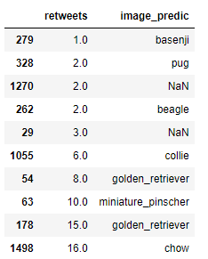

Its graph is:

**least_retweets_dogs.plot(kind='barh',x='image_predic',y='retweets', alpha = 0.5, color='blue');**

**plt.title('The least dog retweets')**

**plt.xlabel('retweets')**

**plt.ylabel('Dog breed');**

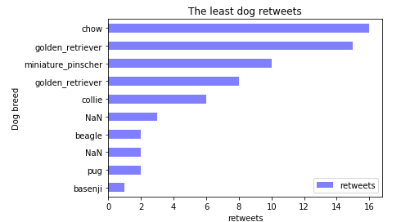

As it was expected, the number the retweets is lower as the least favorites dogs. This make sense because There are few numbers of favorites and as consequences affect the reweets.

1. Plot favorites (like) VS retweets

With whole graph we can plot favorite vs retweets. According with my graph I expect a graph quite linear or exponential which indicate that the number of favorites should be match the number of retweets.

Code was:

**all_data.plot(kind='scatter',x='favorites',y='retweets', alpha = 0.5, color='b');**

**plt.xlabel('Likes')**

**plt.ylabel('Retweets')**

**plt.title('Retweets VS Likes');**

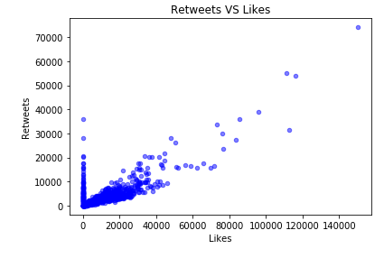

As we saw the last graphs (The most dog retweets and the top 10 with more likes), the number of likes and retweets are bigger with some breeds. So, this last graph confirmed a positively correlated with Likes and retweets. Also, exist some breeds that are not favorite as consequence it has least retweets.

Conclusion

During whole analysis and visualization. I plot the most and least popular dog breeds. In addition, which dog breeds have more 'likes' and retweets. This allowed to verify which retweets vs likes are growing according with the favorites and popular breeds. Also, the least popular favorites make sense with the last graph where there are some points with 1 in like but some of them were retweets.